**Chapter 9: Chemical Equilibrium**

**All Lectures Uploaded on YouTube:**

[**https://tinyurl.com/fkm9-chemistry**](https://tinyurl.com/fkm9-chemistry)

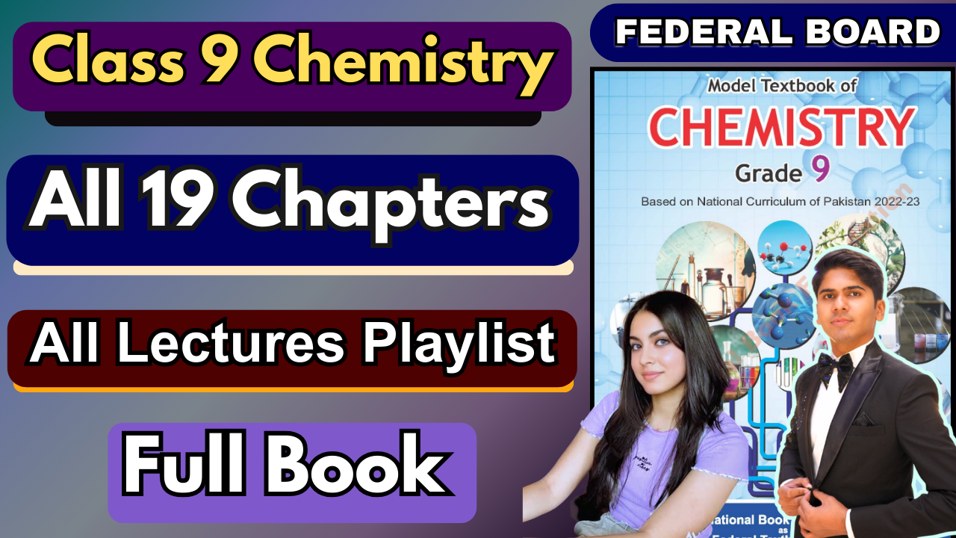

**9.1. Reversible Reactions & Chemical Equilibrium**

Many important chemical reactions in industry (e.g., production of ammonia, sulfuric acid) do not go to completion. Instead, they result in a mixture of reactants and products. In such reactions, the products can react together to re-form the original reactants. These are called reversible reactions.

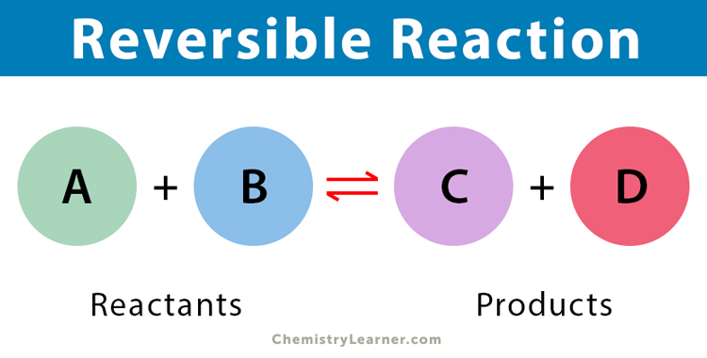

**Key Characteristic:** They proceed in both the forward (reactants → products) and reverse (products → reactants) directions simultaneously under the same conditions.

**Notation:** A reversible reaction is denoted by a double arrow (⇌) in the chemical equation.

Analogy - Physical Equilibrium (Evaporation & Condensation):

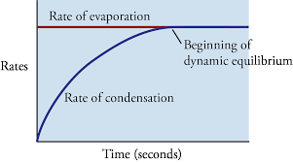

In a closed container, a liquid evaporates to form vapor. Simultaneously, vapor molecules condense back into liquid. Initially, the rate of evaporation > rate of condensation. Eventually, the two rates become equal. At this point, dynamic equilibrium is reached. The amounts of liquid and vapor remain constant, but both processes continue.

**Chemical Equilibrium and How It Is Established**

Chemical Equilibrium is the state of a reversible reaction where the forward and reverse reaction rates are equal.

It is a dynamic equilibrium—the reactions do not stop, but the concentrations (or amounts) of all reactants and products remain constant over time.

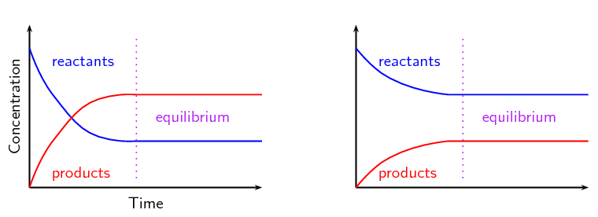

Example: Formation of Sulfur Trioxide (SO₃)

Forward Reaction: 2SO₂(g) + O₂(g) → 2SO₃(g)

Reverse Reaction: 2SO₃(g) → 2SO₂(g) + O₂(g)

**Establishing Equilibrium:**

1. Start: Only SO₂ and O₂ are present. The forward reaction rate is high (high reactant concentration). The reverse rate is zero (no SO₃).

2. Progress: As SO₃ is produced, its concentration increases. The forward rate slows (reactants are used up), and the reverse rate begins to increase (SO₃ decomposes).

3. Equilibrium: The point where forward rate = reverse rate. SO₃ is formed as fast as it decomposes. Concentrations stabilize.

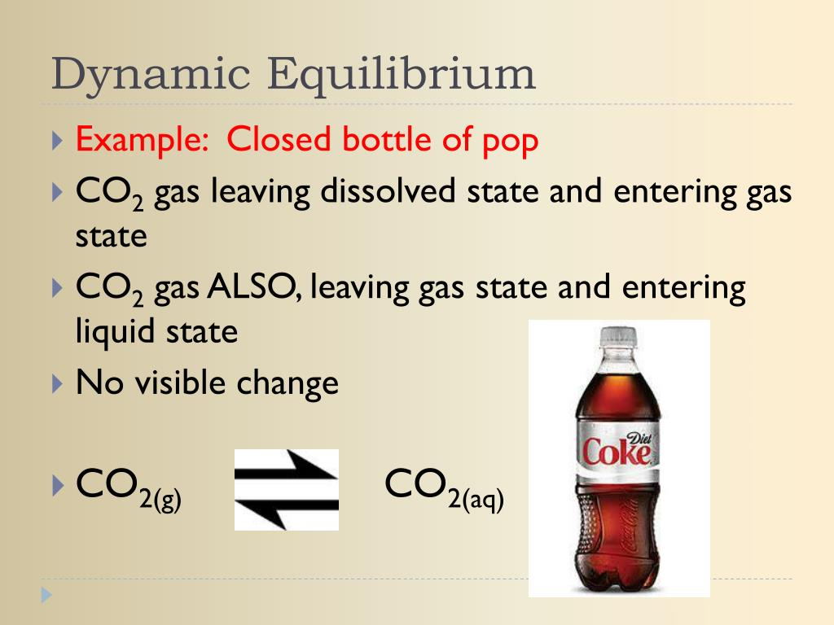

Real-World Example: Fizzy Drinks

CO₂ is dissolved under pressure during manufacturing (forward reaction: CO₂(g) → CO₂(aq)).

When the bottle is sealed, equilibrium exists: CO₂(g) ⇌ CO₂(aq)

Opening the bottle releases pressure, favoring the reverse reaction (CO₂(aq) → CO₂(g)), causing bubbles.

**9.2. Conditions for Maintaining Equilibrium**

For a system to remain at equilibrium, the following physical conditions must be constant:

1. Concentrations of reactants and products.

2. Temperature of the system.

3. Pressure or Volume of the system (especially for gaseous reactions).

If any of these conditions are altered, the equilibrium position will shift to counteract the change (Le Chatelier's Principle, implied in the temperature example).

**9.3. Effect of Heat (Temperature) on Equilibrium**

Changing the temperature of a system at equilibrium will shift the equilibrium position.

This is demonstrated by the reversible dehydration of hydrated salts.

**Activity: Hydrated Copper (II) Sulphate**

∙ Hydrated Form: CuSO₄·5H₂O (Blue solid)

∙ Reaction on Heating (→): CuSO₄·5H₂O(s) → CuSO₄(s) + 5H₂O(g)

∙ Observation: Colour changes from blue to white.

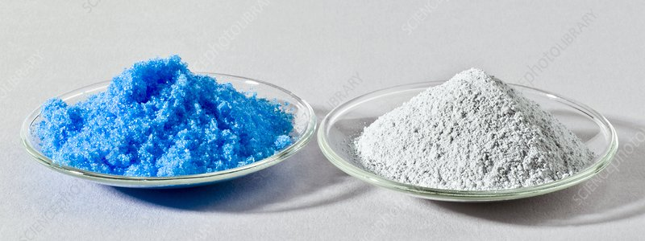

∙ Explanation: Heat removes water of crystallization, forming anhydrous (white) copper(II) sulphate. Equilibrium shifts to the right (towards the anhydrous form). ∙

Reaction on Adding Water (←): CuSO₄(s) + 5H₂O(l) → CuSO₄·5H₂O(s) ∙ Observation: Color changes from white back to blue.

∙ Explanation: Adding water favors the reverse reaction. Equilibrium shifts to the left (towards the hydrated form).

**Parallel Example: Cobalt(II) Chloride**

∙ Hydrated Form: CoCl₂·6H₂O (Pink solid)

∙ Anhydrous Form: CoCl₂ (Blue solid)

∙ Reversible Reaction: CoCl₂·6H₂O(s) ⇌ CoCl₂(s) + 6H₂O(g)

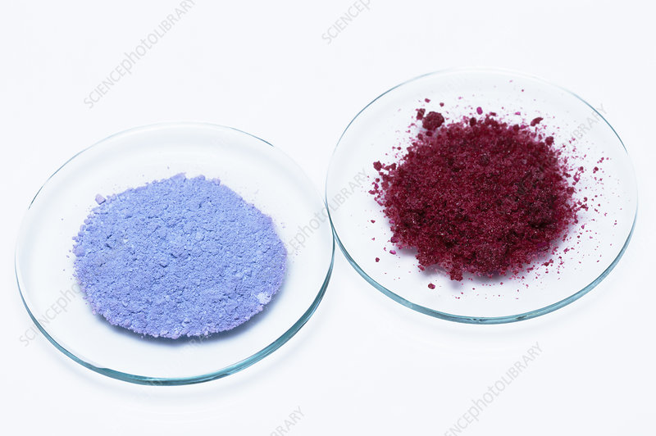

∙ Heating removes water, shifting equilibrium to the right (blue).

∙ Adding water shifts equilibrium to the left (pink).

**Key Concepts**

| **Concept** | **Definition** | **Key Point** |
| --- | --- | --- |
| **Reversible**  **Reaction** | A reaction where products re-form reactants. Proceeds in both directions. | Represented by ⇌.  Never goes to completion. |
| **Chemical**  **Equilibrium** | State where forward and reverse reaction rates are equal. | Dynamic – reactions continue, but concentrations are constant. |
| **Conditions for Equilibrium** | Requires  constant Concentration, Temperature, and Pressure/Volume. | Change in any condition disrupts equilibrium. |
| **Effect of Temperature** | Alters the equilibrium position. Demonstrated by hydration/dehydration of salts. | Heating favors the endothermic direction; Cooling/Adding water favors the exothermic/hydration direction. |

**Important Equations:**

1. 2SO₂(g) + O₂(g) ⇌ 2SO₃(g)

2. CO₂(g) ⇌ CO₂(aq) (Fizzy drink equilibrium)

3. CuSO₄·5H₂O(s) ⇌ CuSO₄(s) + 5H₂O(g)

4. CoCl₂·6H₂O(s) ⇌ CoCl₂(s) + 6H₂O(g)

